----------------------------------------------------------------------------------------------------------------------------------------------
STEP 1 (for new OnCOURSE users)  Using your internet browser  go to thailand2020.cpsctech.org. Click Create New Account button and then you will be redirected to the New Account page.  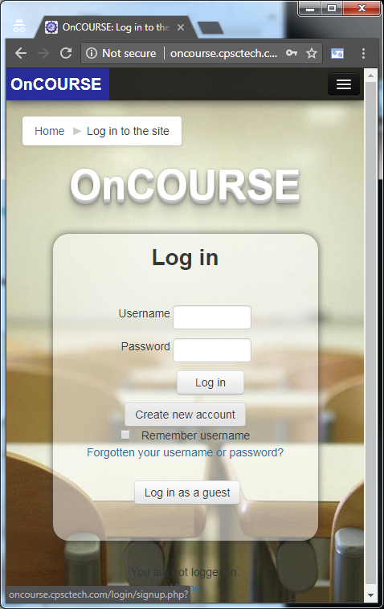  STEP 3  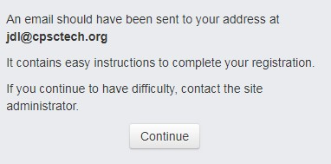  Your email address  You will be asked to confirm your user account from your registered email (eg. ). Check your inbox and open the mail with subject: OnCOURSE account confirmation from sender ict@cpsctech.org  Click the link to complete user account confirmation. | STEP 2  Fill in the new account form then click  ‘Create my new account’ button.  STEP4  Once your account is confirmed, go back to url:  thailand2020.cpsctech.org and type-in the  enrolment key: 2003110202  then click Enrol me.  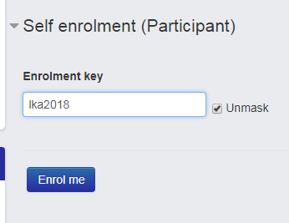  2003110202

---------------------------------------------------------------------------------------------------------------------------------------------

Reset forgotten password

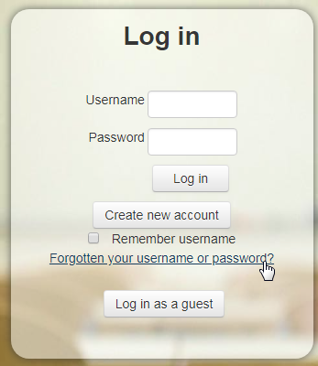
- Click the Forgotten your username or password? link

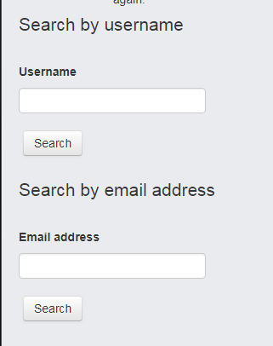
- Key in your Username or Email address, then click Search. You will be receiving Email instruction for resetting your password. If you did not see the Email with reset link, check the Spam or Junk folder of your Email.
Uploading Task in OnCOURSE
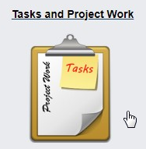
- Click the Task and Project Work Icon

- Click again the small Upload Task Link

- Click Add submission button

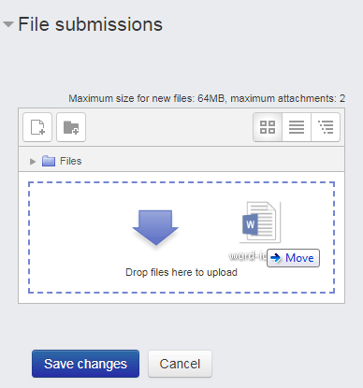
- (Option 1) Using drag and drop feature, documents can be uploaded directly to the internet browser window

- (Option 2) Documents can also upload files using the Add… button.

- Click Save changes when done

